Overall, I ended up generally going for my own thing. I have my own resume already that is good, so I just based it off that one and did shenanigans with HTML.

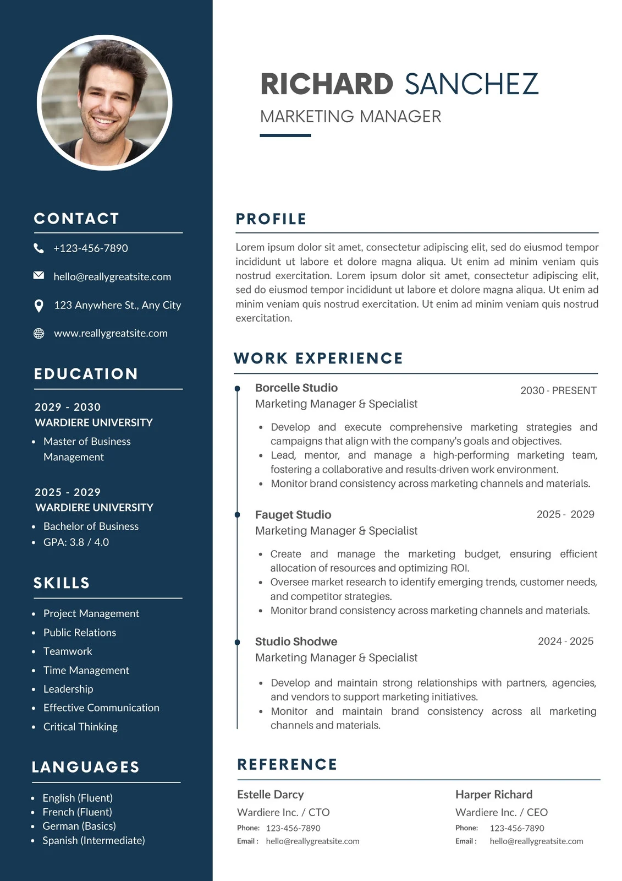

This one was one of the ones that I really liked, The column is really cool, and the whole linear Timeline is my favorite part. Very cool! Really locked in that I would keep the blue look for my own resume.

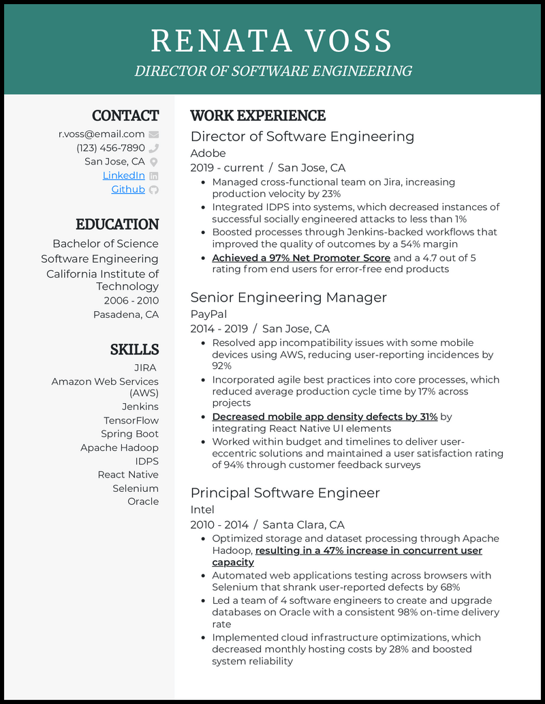

Another situation - I really wanted to get one of those sidebars! I really like that style, with a large sidebar with the sort of quick stop essentials, and then the details in the more paragraph-alike section. Wish I had the time to figure that one out!

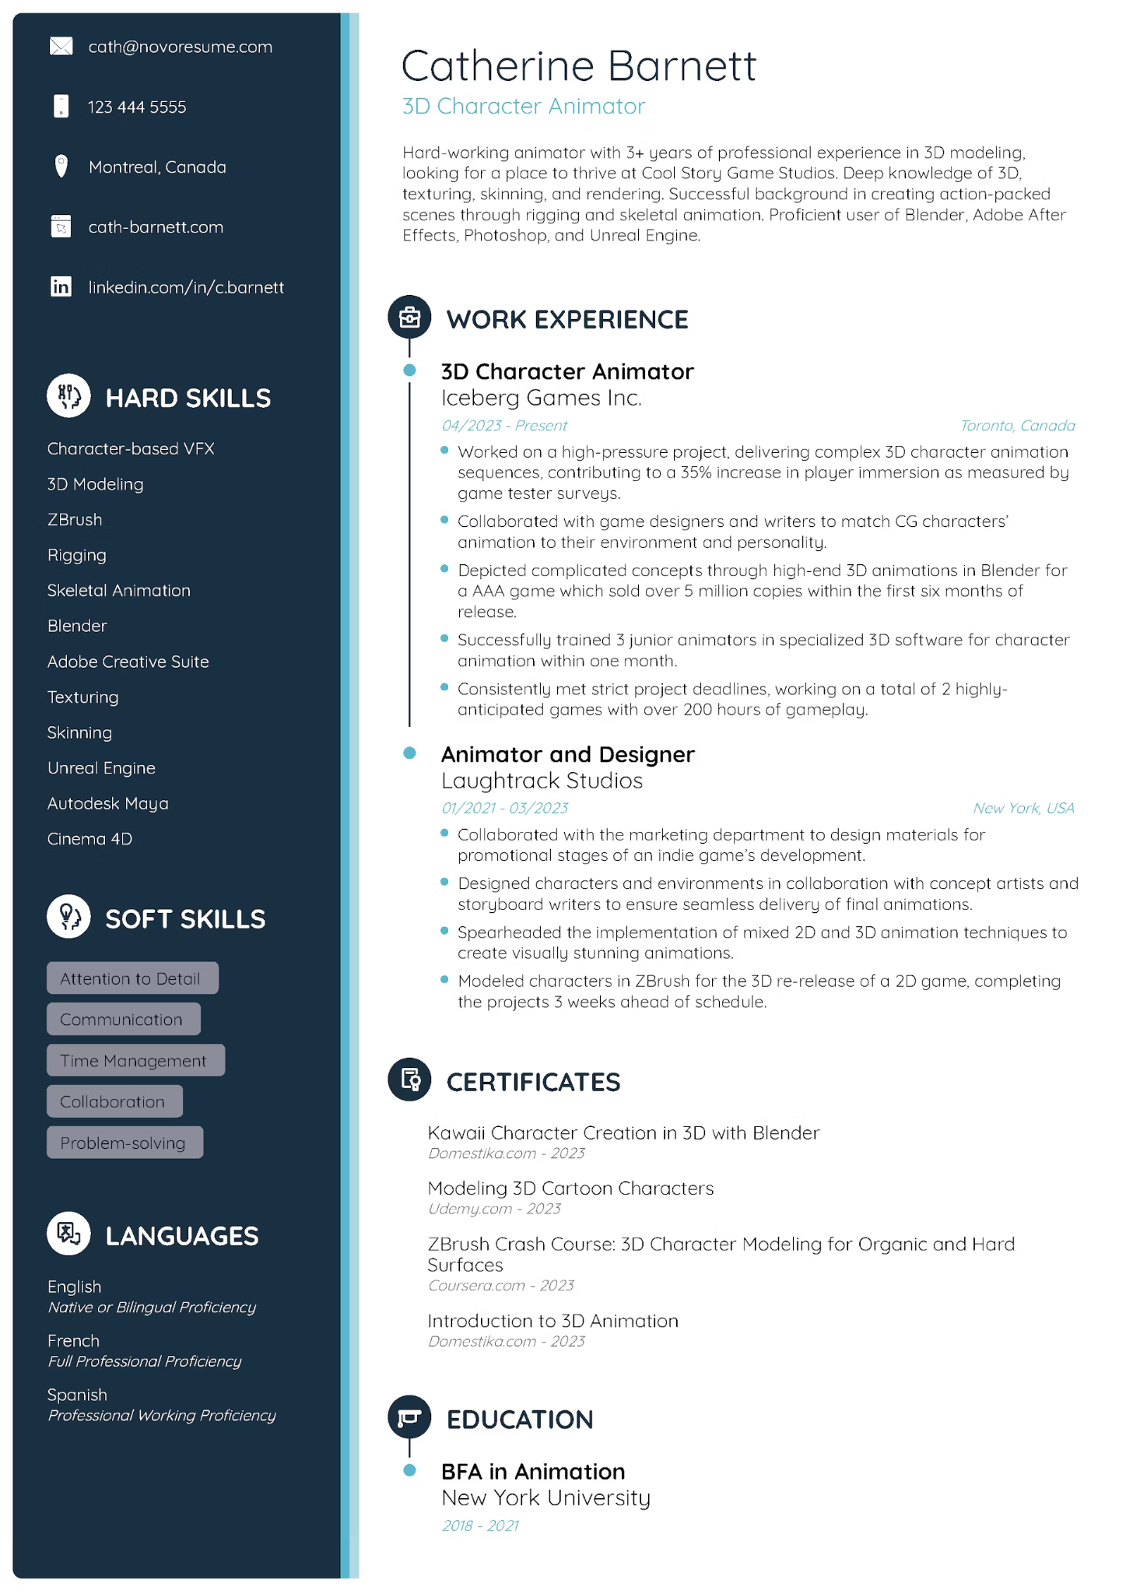

In the future, I ought to take a look at this one. This ‘Catherine Barnett’ does a lot of the things I want to do, and she seems like shes in the field that I eventually want to be - Unreal engine and the such. The Hard skills and Soft skills are something that I should’ve looked into clarifying on, thats a good idea!